Measurement Uncertainty
ISO/ISE 17025-2017 Clause 7.6

Prepared By:  Masab Rasheed | Reviewed By:  Himayat Hussain | Approved By:  Ahmed Umair
AQCM | QCM | CEO
Date: | Date: | Date:

Copyright

The copyright of this procedure, together with all confidential information contained herein is the sole property of QC LAB.
It may be copied in full or in parts only by the Management / personnel and only for the purpose of Company related activities. Disclosure and copying of any information contained within this procedure to any person (s) outside the employee of company without written permission/authorization of the Chief Executive Officer is strictly prohibited.
Amendment Sheet
Date | Revision # | Amendment Detail | Section | DCR | Amendment Approved by
01-10-24 | 01 | Replace issue# with revision# | Header | 17-24 | Chief Executive Officer
01-10-24 | 01 | Deletion of page number from header | Header | 17-24 | Chief Executive Officer
01-10-24 | 01 | QC Lab reporting to CEO for Final Approval | Document Approval | 17-24 | Chief Executive Officer

- Purpose

  - The purpose of this procedure is to determine measurement of uncertainty for the tests in scope of accreditation, where applicable.
- Scope

  - This procedure is applicable tests in the Scope of Accreditation performed at QC LAB testing lab.
- Important Terms

- MU: Measurement Uncertainty
- SOP: Standard operating Procedure
- Accuracy: Closeness of agreement between a measured quantity value and a true quantity value of the measured.
- Analyte: The substance measured from a sample. The characteristic of the substance that is measured is called the measurand, defined below.
- Bias: Estimate of a systematic measurement error.
- Error: Difference between the measured quantity value of the measurand and the reference quantity value of the measurand.
- Precision: Closeness of agreement between indications or measured quantity values obtained by replicate measurements on the same or similar objects under specified conditions.
- Measurement Uncertainty: Non-negative parameter, characterizing the dispersion of the quantity values being attributed to a measurand, based on the information used.
- Measurand: The quantity being measured is the measurand (i.e. the concentration of an analyte).
- Expanded uncertainty: The expanded uncertainty is the combined standard uncertainty (or standard uncertainty, if there is only one component), multiplied by the coverage factor.
- Standard uncertainty: The standard deviation for uncertainty is either for the test or for a component of the test. It can be expressed in the units of the measurement, or a percentage, but all components are expressed in the same terms before they can be combined.
- Combined Standard Uncertainty: Uncertainty of a calculated quantity y, which depends of several measured results or theoretical parameters x and that is expressed as the result of propagation of the standard deviation of all the results.
- Uncertainty Budget: List of sources contributing to the uncertainty of each of the measured values or parameters used in the calculation of the quantity.
- Repeatability conditions: Identical samples prepared at the same time, by the same analyst, under identical conditions, run on the same instruments are repeatability conditions.
- Reproducibility conditions: Reproducibility conditions are identical samples analyzed under different conditions, including any of the following: different times, different equipment, different analysts, or different laboratories.
- Responsible Designations

S. No. | Action | Responsibility
4.1 | Each operator/ Analyst for respective test. | Analyst
4.2 | To ensure estimation of uncertainty with standard test Method. | Quality Control Manager
4.3 | To ensure validated and up to date version is used for Uncertainty calculation sheet is used. | Quality Control Manager
4.4 | To Ensure results and data of uncertainty calculations are correct and attached with results. | Quality Control Manager
4.5 | Are responsible for the collection of data and the determination of the estimated uncertainty for analytical methods in use. | Analyst
4.6 | Results shall be recorded on the Analyst log books / Worksheets. | Analyst
4.7 | To Authorized this Procedure and relevant documents involving their particular operations or functions. | Quality Control Manager
4.8 | For safe utilization of written procedure. | Quality Control Manager
4.9 | is the final approving authority for resources | CEO

5. Procedure

  - Each measurement made in a laboratory has a corresponding uncertainty assigned to the calibration value. The uncertainty is directly related to the measurement parameter (scope), range of the measurement, the equipment or measurement process being used (affecting precision), and the standards available with associated uncertainties.
  - This uncertainty analysis process follows the following eight steps:
    - Specify the measurement process;
    - Identify and characterize uncertainty components;
    - Quantify uncertainty components in applicable measurement units;
    - Convert uncertainty components to standard uncertainties in units of the measurement result;
    - Calculate the combined uncertainty;
    - Expand the combined uncertainty using an appropriate coverage factor;
    - Evaluate the expanded uncertainty against appropriate tolerances, user requirements, and laboratory capabilities; and
    - Report correctly rounded uncertainties with associated measurement results.
  - Specify the process. (Step-1)
    - Clearly define the measurand(s) and specify the measurement process in question, including the item being measured and the input quantities upon which it depends.
    - This will usually require a quantitative expression related to the process (i.e., a measurement equation).
  - Identify and characterize uncertainty sources. (Step-2)
    - Identify all possible sources of uncertainty in a comprehensive list, characterizing them based on the evaluation method that will be used to quantify them (Type A, statistical methods or Type B, scientific judgment) and to categorize them based on their relatedness with something such as an uncertainty budget table.

Example uncertainty budget table. Uncertainty Component Description | Symbol | Source | Type (A or B) | Typical Distribution
Standard uncertainty from the measurement process | UA | Process | A | Normal
Standard uncertainty for the standards | UB | Calibration Certificate | B | See Certificate
Standard uncertainty due to other factors | UO | Analysis or References | B | Varies
    - Standard uncertainty from the measurement process, UA, (Type A evaluation).

    - Standard deviation from a measurement assurance chart or control chart.
      - The value is obtained from the control chart data and the current knowledge that the measurements are in a state of statistical control. The control chart data must reflect the measurement process being performed.
    - Standard deviation from a series of replicate measurements.
      - Measure a stable test object, no two measurements of which should be made on the same day. Calculate the standard deviation in the conventional manner to obtain the standard deviation of the process.

      - When a set of several repeated readings has been taken (for a Type A estimate of uncertainty), the mean, x, and estimated standard deviation, s, can be calculated for the set. From these, the estimated standard uncertainty, u, of the mean is calculated from:
Where n was the number of measurements in the set.

Standard uncertainty for the standards, UB (Type B evaluation).
      - When using standards calibrated by another laboratory. The information for the standards comes from the calibration report, generally reported as an expanded uncertainty with its coverage factor (k). The expanded uncertainty is simply divided by the stated k value to obtain the combined uncertainty for the standard, uc.

      - When using more than one standard (Type B evaluation). When more than one standard is used in a calibration, the standard uncertainty for each source uB1, uB2, uB3, etc., is included in the RSS equation if the standards have had independent calibrations. Standards with independent calibrations are combined by standard root sum square methods.
      - Standard uncertainty due to other factors, uo (Type B evaluation.) These are factors related to the measurement equation, but distinct from the standard uncertainties associated with the process and the standards. These items are often much smaller in a well-controlled process than the standard uncertainties associated with the process and the standards. Each component that is considered is included as an additional standard uncertainty uo1, uo2, uo3, etc., and included in the RSS equation when data shows these factors to be significant.
      - Where the information is scarcer (in some Type B estimates), might only be able to estimate the upper and lower limits of uncertainty. Have to assume the value is equally likely to fall anywhere in between, i.e. a rectangular or uniform distribution. The standard uncertainty for a rectangular distribution is found from:
Where a is the semi-range (or half-width) between the upper and lower limits.
      - Rectangular or uniform distributions occur quite commonly, but if have good reason to expect some other distribution, then should base your calculation on that.

  - Quantify uncertainty estimates. (Step 3)
    - All uncertainty estimates identified must be quantified in units that represent the measured values. Type A methods of evaluation usually provide quantified estimates in the units of interest. Type B methods of evaluation may be conducted with spreadsheets using the basic expression identified. Quantify the components and determine the standard uncertainty for each component of each source using rectangular distribution (√3).

  - Convert all factors to standard uncertainties. (Step 4)
    - In cases where the uncertainty factors were determined statistically (Type A methods), the standard deviation is used to represent the standard uncertainty.

  - Calculate the combined uncertainty. (Step 5)
    - The combined standard uncertainty, uc, includes the standard uncertainty reported for the standards used, us, the standard uncertainty of the measurement process, sp, the standard uncertainty from other sources, uo, which includes all other factors the laboratory considers significant, the standard uncertainty due to factors related to the measured item but unrelated to the measurement process, uu, and finally. The standard uncertainties are usually combined using the root-sum-of-the-squares (RSS) method as follows:
Uc = √ (Type A)²+ (Type B)²

  - Calculate the expanded uncertainty. (Step 6)
    - The combined standard uncertainty is then multiplied by a coverage factor, k, to provide a level of confidence of approximately 95 % or 99 %, respectively (depending on what is required by the customer, but most often 95 %). The equation used to determine the expanded uncertainty is as follows:
U = u * k
Where k = 2
    - Most commonly, scale the overall uncertainty by using the coverage factor k = 2, to give a level of confidence of approximately 95 percent. (k = 2 is correct if the combined standard uncertainty is normally distributed. This is usually a fair assumption, but the reasoning behind this is explained elsewhere,
    - Some other coverage factors (for a normal distribution) are:

k = 1 for a confidence level of approximately 68 percent
k = 2.58 for a confidence level of 99 percent
k = 3 for a confidence level of 99.7 percent.

  - Evaluate the expanded uncertainty. (Step7)
    - The expanded uncertainty must be evaluated. The first level of evaluation should be to determine if the calculated results make sense and are reasonable, to ensure that obvious blunders have not been made in the calculations. Evaluation may be against established criteria such as tolerance limits, customer requirements, and/or calibration and measurement capabilities.

  - Report the uncertainty. (Step 8)
    - Once the uncertainty has been calculated, the uncertainty is reported to the same number of significant figures as the result. In most cases, two significant figures suffice. The estimate should also state the level of confidence associated with the coverage factor. Finally, the uncertainty is reported in the same units as the result.

    - Decision Rules: QC LAB Fertilizer testing laboratory follow binary statement for simple acceptance decisions rule (e.g. Fail/ Pass/ conditionally fail/ conditionally fail) are report on test reports. (w=0)

The QC LAB has developed four rules to report the result

    - Statement of conformity are reported as
- Pass
- Fail
- Conditionally pass
- Conditionally fail

Rule 1: If the test results plus or minus and reported uncertainty within rage, then result will be fall in pass category.

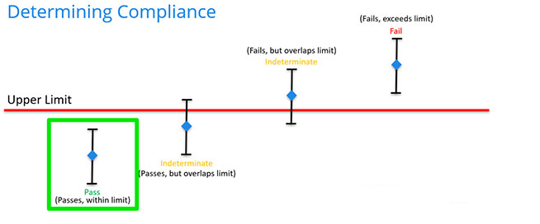

b. Rule 2:

When the measurement result plus or minus and the measuring uncertainty exceed the within the range, then result will be fall in FAIL category.

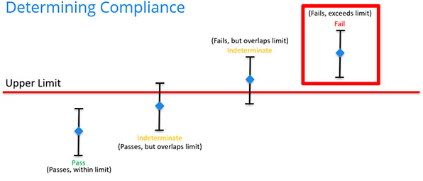

C. Rule 3:

If the measuring result plus or minus and reported uncertainty most likely towards pass category and minimum portion fall in fail side then the QC LAB fertilizer testing laboratory follow the rule 3, the result will be Conditionally pass

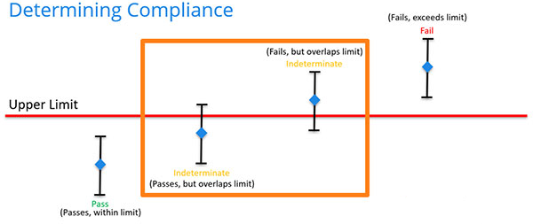

D. Rule 4
If the measuring result plus or minus and reported uncertainty most likely towards fail category and minimum portion fall in pass side then the QC LAB fertilizer testing laboratory follow the rule 4, the result will be Conditionally fail.
QC LAB water testing Laboratory follow the confidence level 95%,

    - When the decision rule is not provided, the QC LAB fertilizer Testing laboratory must document the decision rule and account for the level of risk associated with the decision rule used.
    - Decision rules used by QC LAB shall be documented and all communication with customer shall be maintained.

- Relevant Documents

- Uncertainty Calculation sheet (QCL-FRM-13.01)
- Decision Rule (QCL-FRM-13.02)

